BANK LOAN REPORT QUERY DOCUMENT

1. BANK LOAN REPORT | SUMMARY

KPIs

Total Loan Applications

SELECT COUNT(id) as Total_Loan_Applications FROM financial_loan;

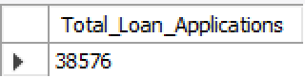

MTD Loan Applications

SELECT COUNT(id) as MTD_Total_Applications FROM financial_loan WHERE month(issue_date)=12;

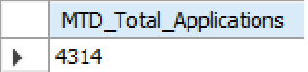

PMTD Loan Applications

SELECT COUNT(id) as PMTD_Total_Applications FROM financial_loan WHERE month(issue_date)=11;

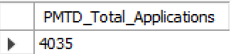

Total Funded Amount

SELECT Sum(loan_amount) as Total_Funded_Amount FROM financial_loan;

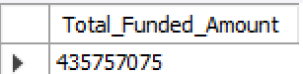

MTD Total Funded Amount

SELECT Sum(loan_amount) as MTD_Total_Funded_Amount FROM financial_loan

WHERE MONTH(issue_date)=12;

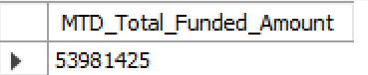

PMTD Total Funded Amount

SELECT Sum(loan_amount) as PMTD_Total_Funded_Amount FROM financial_loan

WHERE MONTH(issue_date)=11;

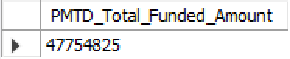

Total Amount Received

SELECT Sum(total_payment) as Total_Received_Amount FROM financial_loan;

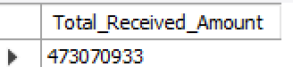

MTD Total Amount Received

SELECT Sum(total_payment) as MTD_Total_Received_Amount FROM financial_loan

WHERE Month(issue_date)=12;

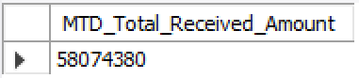

PMTD Total Amount Received

SELECT Sum(total_payment) as PMTD_Total_Received_Amount FROM financial_loan

WHERE Month(issue_date)=11;

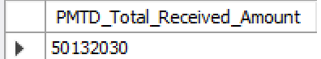

Average Interest Rate

SELECT ROUND(AVG(int_rate)*100,2) as Average_Interest_Rate FROM financial_loan;

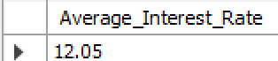

MTD Average Interest Rate

SELECT ROUND(AVG(int_rate)*100,2) as MTD_Average_Interest_Rate FROM financial_loan

WHERE Month(issue_date)=12;

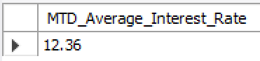

PMTD Average Interest Rate

SELECT ROUND(AVG(int_rate)*100,2) as PMTD_Average_Interest_Rate FROM financial_loan

WHERE Month(issue_date)=11;

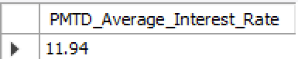

Average DTI

SELECT ROUND(AVG(dti)*100,2) as Average_DTI FROM financial_loan;

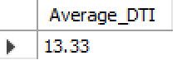

MTD Average DTI

SELECT ROUND(AVG(dti)*100,2) as MTD_Average_DTI FROM financial_loan

WHERE Month(issue_date)=12;

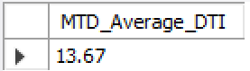

PMTD Average DTI

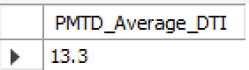

Good Loans Issued

Good Loan Percentage

SELECT (COUNT(CASE WHEN loan_status = 'Fully Paid' OR loan_status = 'Current' THEN id END) *100.0) / COUNT(id) AS Good_Loan_Percentage FROM financial_loan;

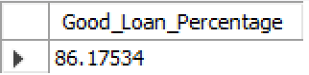

Good Loan Applications

SELECT COUNT(id) as Good_Loan_Applications FROM financial_loan

WHERE loan_status = 'Fully Paid' OR loan_status = 'Current';

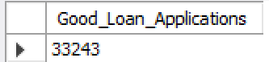

Good Loan Funded Amount

SELECT SUM(loan_amount) as Good_Loan_Funded_Amount FROM financial_loan

WHERE loan_status = 'Fully Paid' OR loan_status = 'Current';

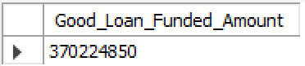

Good Loan Received Amount

SELECT SUM(total_payment) as Good_Loan_Received_Amount FROM financial_loan

WHERE loan_status = 'Fully Paid' OR loan_status = 'Current';

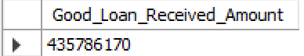

Bad Loans Issued

Bad Loan Percentage

SELECT (COUNT(CASE WHEN loan_status='Charged Off' THEN id END)*100) / COUNT(id)

AS Bad_Loan_Percentage FROM financial_loan;

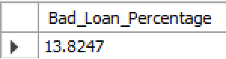

Bad Loan Applications

SELECT COUNT(id) as Bad_Loan_Applications FROM financial_loan

WHERE loan_status = 'Charged Off';

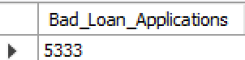

Bad Loan Funded Amount

SELECT SUM(loan_amount) as Bad_Loan_Funded_Amount FROM financial_loan

WHERE loan_status = 'Charged Off';

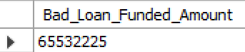

Bad Loan Received Amount

SELECT SUM(total_payment) as Bad_Loan_Received_Amount FROM financial_loan

WHERE loan_status = 'Charged Off';

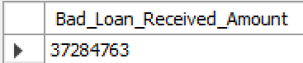

Loan Status

SELECT

loan_status,

COUNT(id) as Loan_Count,

SUM(total_payment) as Total_Amount_Received,

SUM(loan_amount) as Total_Funded_Amount,

AVG(int_rate)*100 as Interest_Rate,

AVG(dti)*100 as DTI

FROM financial_loan GROUP BY loan_status;

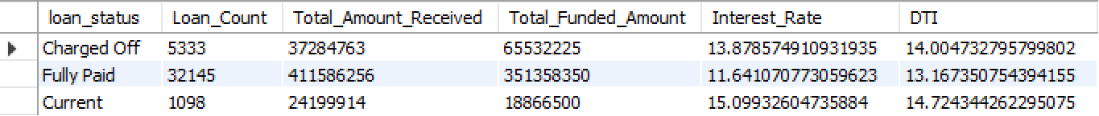

MTD Amount Funded and Amount Received

SELECT loan_status,

SUM(total_payment) as MTD_Total_Amount_Received,

SUM(loan_amount) as MTD_Total_Funded_Amount

FROM financial_loan

WHERE Month(issue_date)=12

GROUP BY loan_status;

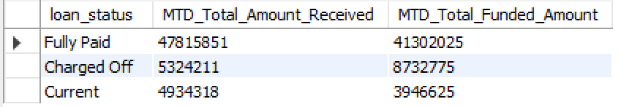

1. BANK LOAN REPORT | OVERVIEW

Month

SELECT MONTH(issue_date) as Month_Number,

MONTHNAME(issue_date) as Month_Name,

COUNT(id) as Total_Loan_Applications,

SUM(loan_amount) as Total_Funded_Amount,

SUM(total_payment) as Total_Received_Amount

FROM financial_loan

GROUP BY MONTH(issue_date),MONTHNAME(issue_date)

ORDER BY MONTH(issue_date);

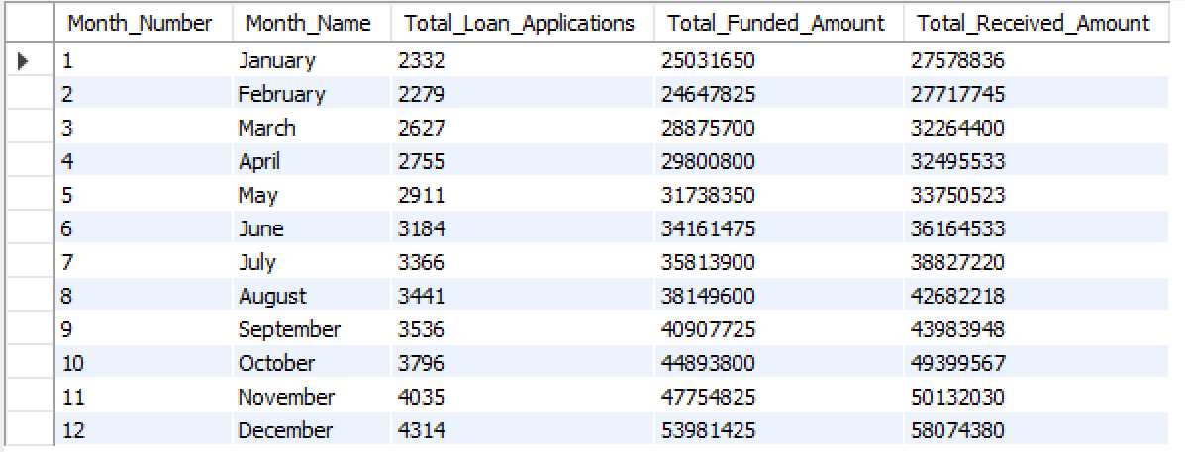

State

SELECT address_state as State,

COUNT(id) as Total_Loan_Applications,

SUM(loan_amount) as Total_Funded_Amount,

SUM(total_payment) as Total_Received_Amount

FROM financial_loan

GROUP BY address_state

ORDER BY address_state;

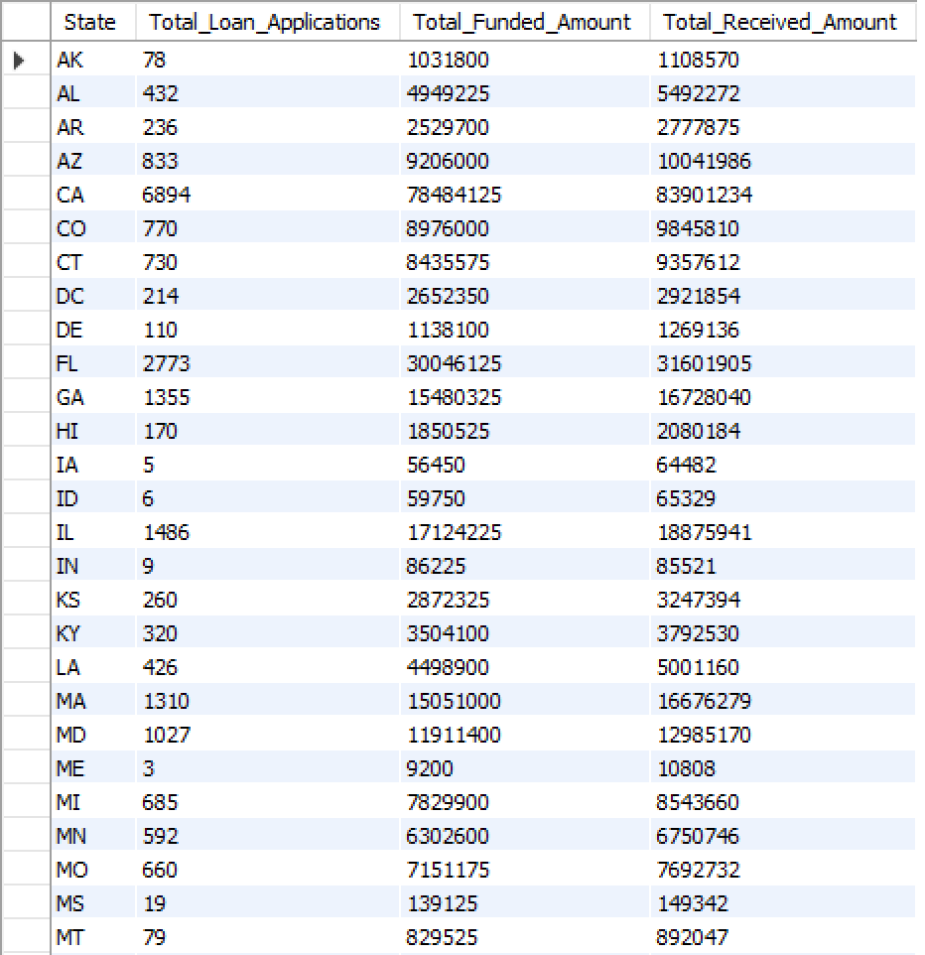

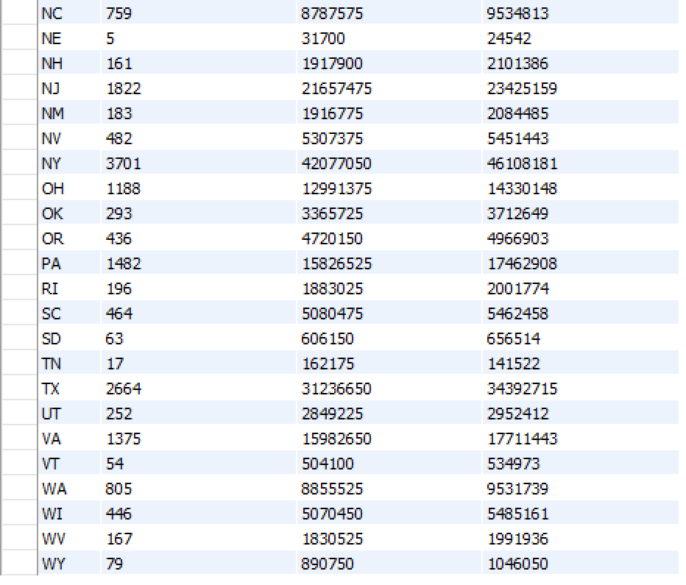

Term

SELECT term,

COUNT(id) as Total_Loan_Applications,

SUM(loan_amount) as Total_Funded_Amount,

SUM(total_payment) as Total_Received_Amount

FROM financial_loan

GROUP BY term

ORDER BY term;

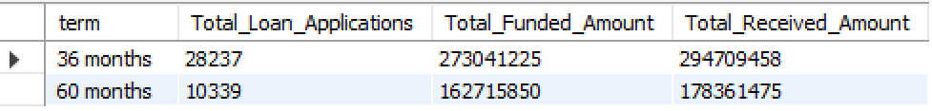

Employee Length

SELECT emp_length as Employee_Length,

COUNT(id) as Total_Loan_Applications,

SUM(loan_amount) as Total_Funded_Amount,

SUM(total_payment) as Total_Received_Amount

FROM financial_loan

GROUP BY emp_length

ORDER BY emp_length;

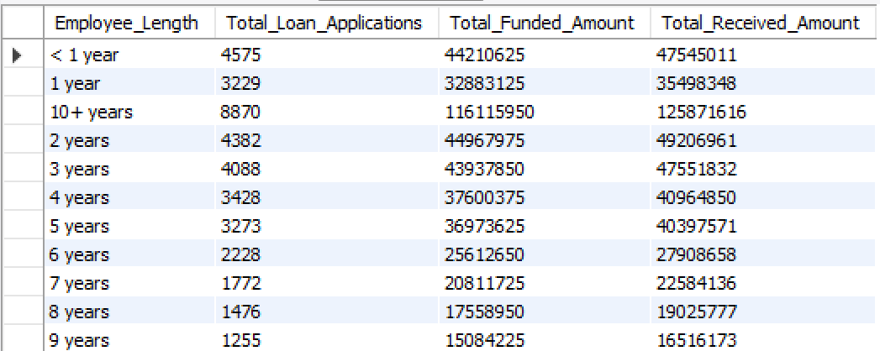

Purpose

SELECT purpose as Purpose,

COUNT(id) as Total_Loan_Applications,

SUM(loan_amount) as Total_Funded_Amount,

SUM(total_payment) as Total_Received_Amount

FROM financial_loan

GROUP BY purpose

ORDER BY purpose;

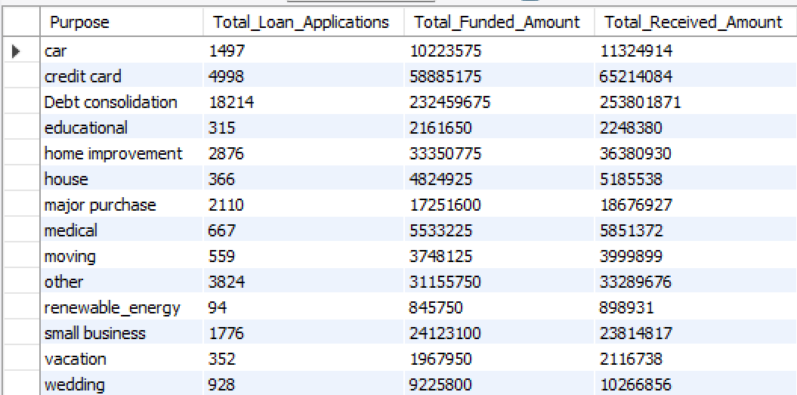

Home Ownership

SELECT home_ownership as Home_Ownership,

COUNT(id) as Total_Loan_Applications,

SUM(loan_amount) as Total_Funded_Amount,

SUM(total_payment) as Total_Received_Amount

FROM financial_loan GROUP BY home_ownership ORDER BY home_ownership;

